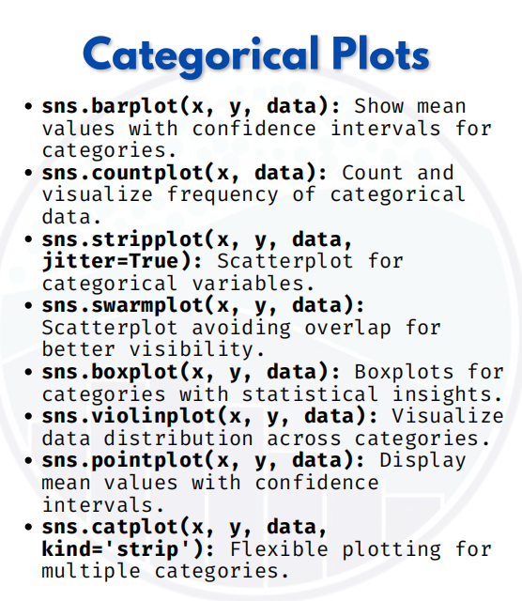

CATEGORICAL PLOT

import seaborn as sns
import matplotlib.pyplot as plt
import pandas as pd

# Sample data
data = pd.DataFrame({
'Subject': ['Math', 'Math', 'Math', 'Science', 'Science', 'Science',
'English', 'English', 'English'] * 2,
'Marks': [85, 90, 78, 88, 76, 92, 80, 75, 85,
60, 65, 70, 55, 58, 68, 72, 74, 69],
'Gender': ['Male']*9 + ['Female']*9
})

1. Barplot – Mean values with confidence intervals
sns.barplot(x="Subject", y="Marks", data=data)
plt.show()
Shows average marks per subject.

2. Countplot – Frequency of categories
sns.countplot(x="Subject", data=data)
plt.show()
Shows how many students took each subject.

3. Stripplot – Scatterplot with jitter
sns.stripplot(x="Subject", y="Marks", data=data, jitter=True)
plt.show()
Displays individual student marks with slight random spread.

4. Swarmplot – Scatterplot avoiding overlap
sns.swarmplot(x="Subject", y="Marks", data=data)
plt.show()
Similar to stripplot, but no overlap, clearer.

5. Boxplot – Statistical summary
sns.boxplot(x="Subject", y="Marks", data=data)
plt.show()
Shows median, quartiles, and outliers of marks per subject.

6. Violinplot – KDE + Boxplot
sns.violinplot(x="Subject", y="Marks", data=data)
plt.show()
Combines distribution shape + boxplot summary.

7. Pointplot – Mean values with confidence intervals
sns.pointplot(x="Subject", y="Marks", data=data)
plt.show()
Plots subject-wise mean marks with error bars.

8. Catplot – Flexible categorical plotting
sns.catplot(x="Subject", y="Marks", data=data, kind="strip")
plt.show()
Creates a categorical plot (here same as stripplot, but flexible for grids).

